C code:

#include <iostream>

#include <string>

#include "../Shared/dspf.hpp"

void resample(dsig hsig, int U, int D, DSPFile& in, DSPFile& out) {

// Determine bounds on computed arrays

const int L = (int)hsig.size();

const int IOBUFFSIZE = 1024;

// Adjust the header on the output file

out.Header = in.Header;

out.Header.dim0 = (out.Header.dim0 * U) / D;

out.Header.dim1 = (out.Header.dim1 * U) / D;

out.write_h();

// It would be really nice if Dr. Gunther explained in his slides what the heck this is...

int M = L / U + ((L % U) > 0);

int N = M * U; // Padded impulse response length

int d = 0, k = 0;

float* x = new float[L];

float* h = hsig.data();

float

xbuff[IOBUFFSIZE],

ybuff[IOBUFFSIZE];

// Zero out circular buffer to clear garbage

for (int i = 0; i < M; ++i) { x[i] = 0; }

//x[i] = in.read_1();

int xlen = in.read_n(xbuff, IOBUFFSIZE);

int ylen = 0;

while (xlen > 0) {

for (int i = 0; i < xlen; ++i) {

k = (k + M - 1) % M;

x[k] = xbuff[i];

if (d == 0) { // Downsampling discards D - 1 values

for (int j = 0; j < U; ++j) {

float y = 0.0; int m = 0, n = 0;

// Upsampling creates 0 every U elements of x (skipping over h because convolution is associative)

for (; n < M; ++n, m += U) {

y += h[m + j] * x[(n + k) % M];

}

ybuff[ylen++] = y;

if (ylen == IOBUFFSIZE) {

out.write_d(ybuff, ylen);

ylen = 0;

}

}

d = D - 1;

} else { --d; }

}

xlen = in.read_n(xbuff, IOBUFFSIZE);

}

if (ylen > 0) {

out.write_d(ybuff, ylen);

ylen = 0;

}

delete[] x;

//delete[] h;

}

int main() {

int argc = 6;

const char* argv[6] = { "Lab 4.exe",

"output\\lpf_U2_D1.bin",

"output\\galway11_mono_45sec.bin",

"output\\galway11_U2_D1.bin",

"2", "1" };

//int main(int argc, char** argv) {

int U, D;

std::string h, in, out;

if (argc != 6) {

std::cout << "Invalid Args" << std::endl;

system("pause");

return -1;

}

h = std::string(argv[1]);

in = std::string(argv[2]);

out = std::string(argv[3]);

U = atoi(argv[4]);

D = atoi(argv[5]);

DSPFile lpf(h), fin(in), fout(out, DSP::Mode::Write);

resample(lpf.read_all(), U, D, fin, fout);

system("pause");

return 0;

}

Matlab:

clear all**;**

% Parse the audio

**[**x**,** fs**]** **=** audio2bin**(**'galway11_mono_45sec.wav'**);**

h **=** lpf_resamp**(**2**,** 1**);**

plotFFT**(**h**,** 10**);**

plot_spectrogram**(**x**,** 10**,** fs**);**

soundsc**(**x**(**1**:**10**\***fs**),** fs**);**

**[**x_rs**,** fs_rs**]** **=** bin2audio**(**'galway11_U2_D1.bin'**);**

plot_spectrogram**(**x_rs**,** 8**,** fs_rs**);**

**function** **[**h**]** **=** lpf_resamp**(**U**,** D**)**

N **=** max**([**U D**]);**

fpass **=** 0.9**/(**2**\***N**);**

fstop **=** 1.1**/(**2**\***N**);**

f1 **=** **(**fstop **+** fpass**)/**2**;**

f2 **=** **(**fstop **-** fpass**)/**2**;**

L **=** 100**;**

n **=** **(-**L**:**L**).';**

h **=** **(**1**/**N**)\***sinc**(**2**\***f1**\***n**).\***sinc**(**2**\***f2**\***n**);**

% Write out the filter file

file **=** sprintf**(**'output\\lpf_U%d_D%d.bin'**,** U**,** D**);**

fid **=** fopen**(**file**,** 'wb'**);**

fwrite**(**fid**,** **[**1 1 length**(**h**)** 1 0**],** 'int'**);**

fwrite**(**fid**,** h**,** 'float'**);**

fclose**(**fid**);**

**end**

**function** **[]** **=** plot_spectrogram**(**f**,** size**,** Fs**)**

NFFT **=** 2**^**size

spectrogram**(**f**,** hamming**(**NFFT**),** round**(**0.8**\***NFFT**),** NFFT**,** Fs**);**

**end**

**function** **[]** **=** plotFFT**(**f**,** size**)**

NFFT **=** 2 **^** size**;**

freq **=** **(**0**:**NFFT**-**1**)/**NFFT**;**

plot**(**freq**,** 20**\***log10**(**abs**(**fftshift**(**fft**(**f**,** NFFT**)))));**

**end**

So I’ve had a problem getting up-sampling to behave properly. I’ve compared with other students who have got this lab working, as well as Dr. Gunther’s code (it’s efficient, but not easily understandable or self-documenting, and he doesn’t cover it in his slides, and we don’t talk about it in class, </vent>) and can find no disparities. My down-sampling appears to work properly.

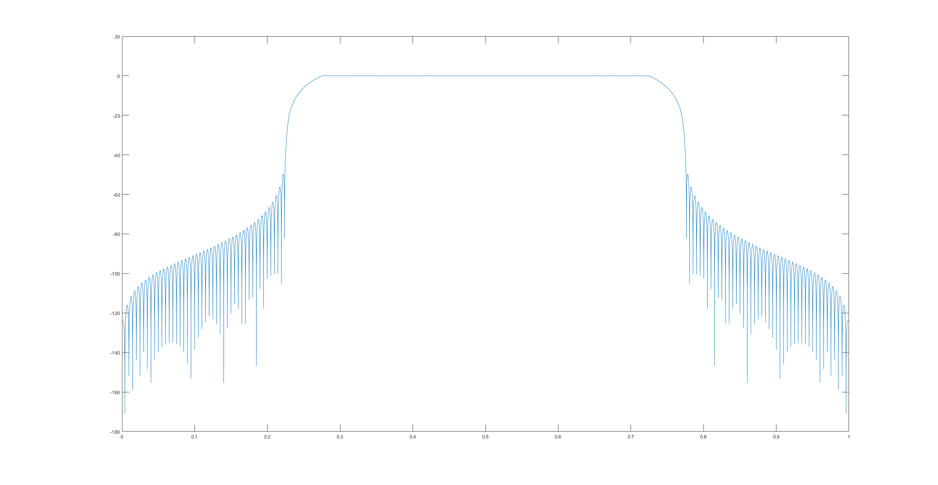

Above is the filter for up-sampling by 2. This appears to match what everyone else is getting (note I use fftshift, so the “moustache” is split over the frequency boundary).

You can see down-sampling by 5 (used a slightly different filter but it has the same form, just narrower) results in correct behavior.

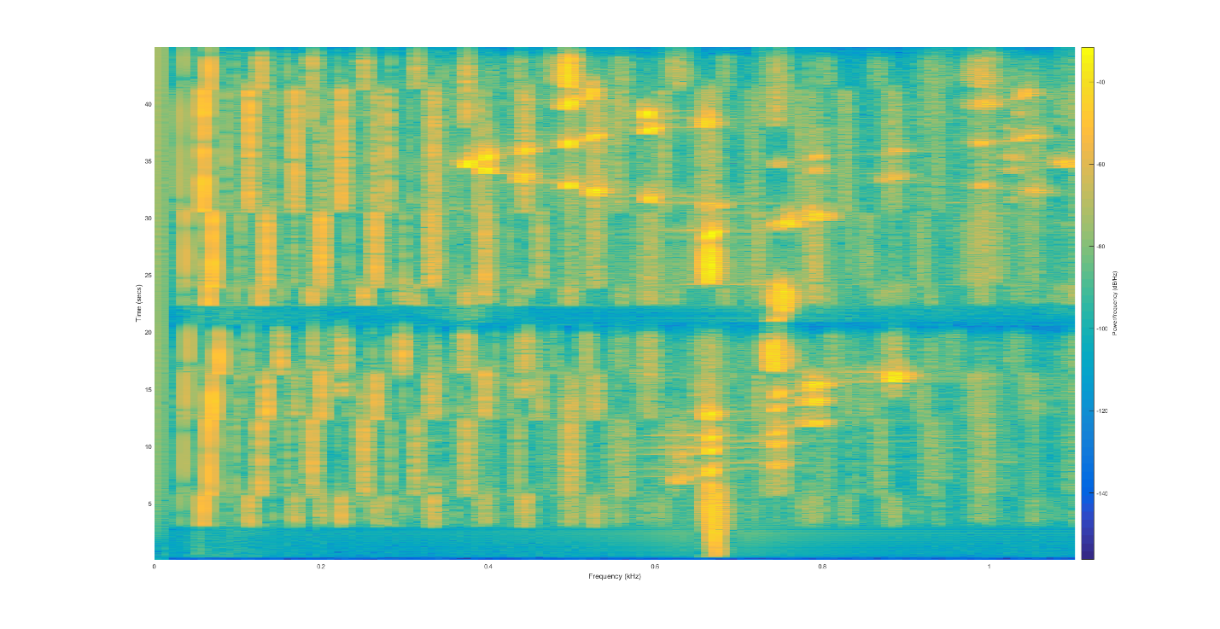

But I expect for up-sampling by 2 half of the screen to be blue. Instead I see aliasing….

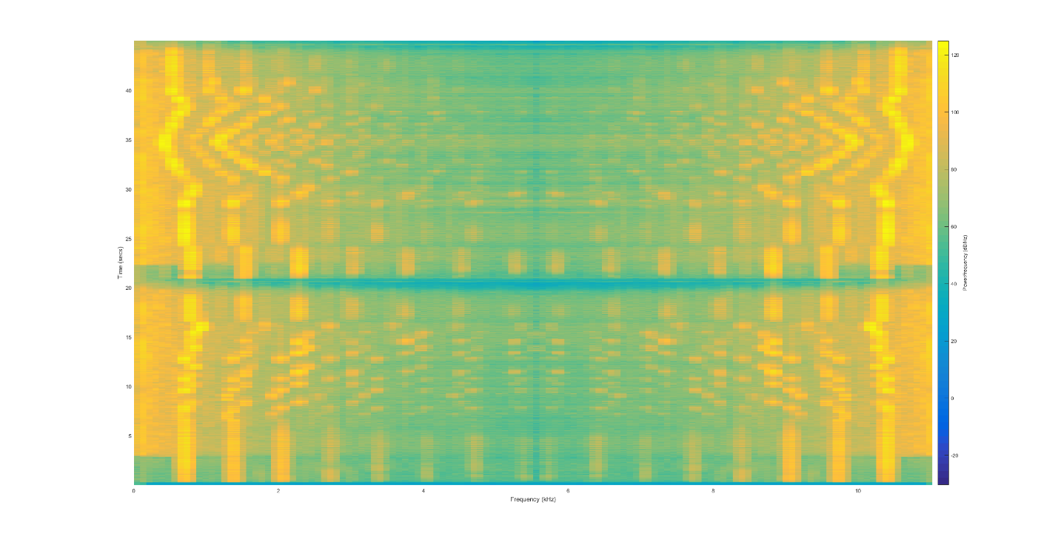

One of the things I looked at in debugging was if I did the convolution when hard-coding U = 1 (so the filter should make it look squeezed in half).

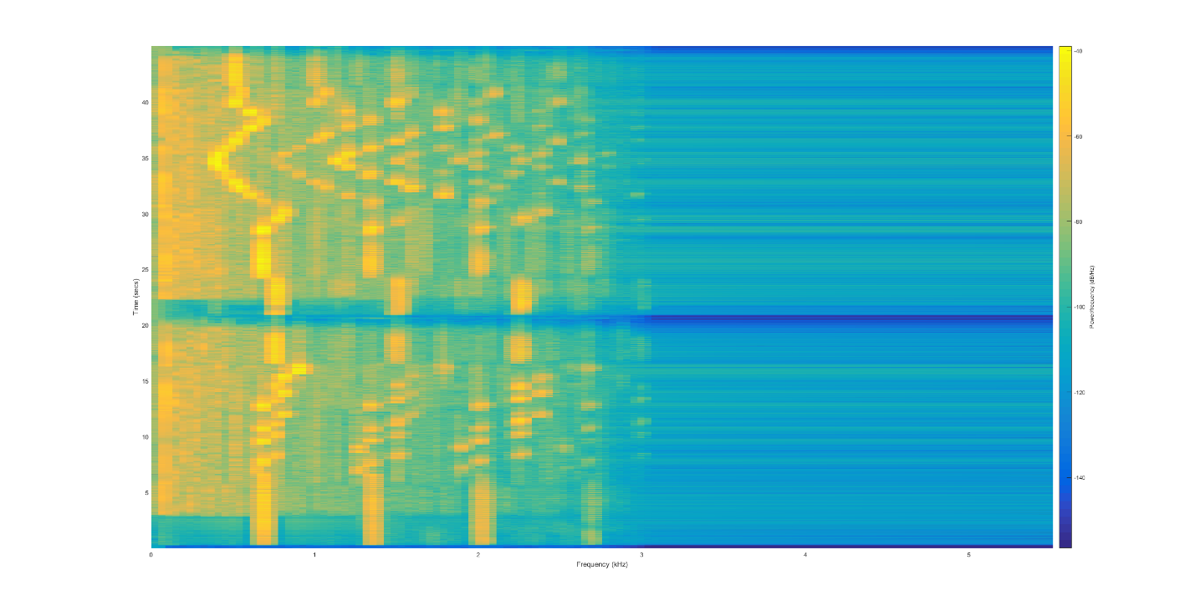

This graph looks about right except the scale should be twice what it is on the frequency axis. I can’t figure out what the deal is here, honestly. When I set U = 2 again in my c code I see this wacky aliasing at f=10, instead of a cutoff at f=5. Where as in U = 1 there is a cutoff at f=2.5 (and null space up to f=5).